User on checkout form and filled the details with invalid credit card number

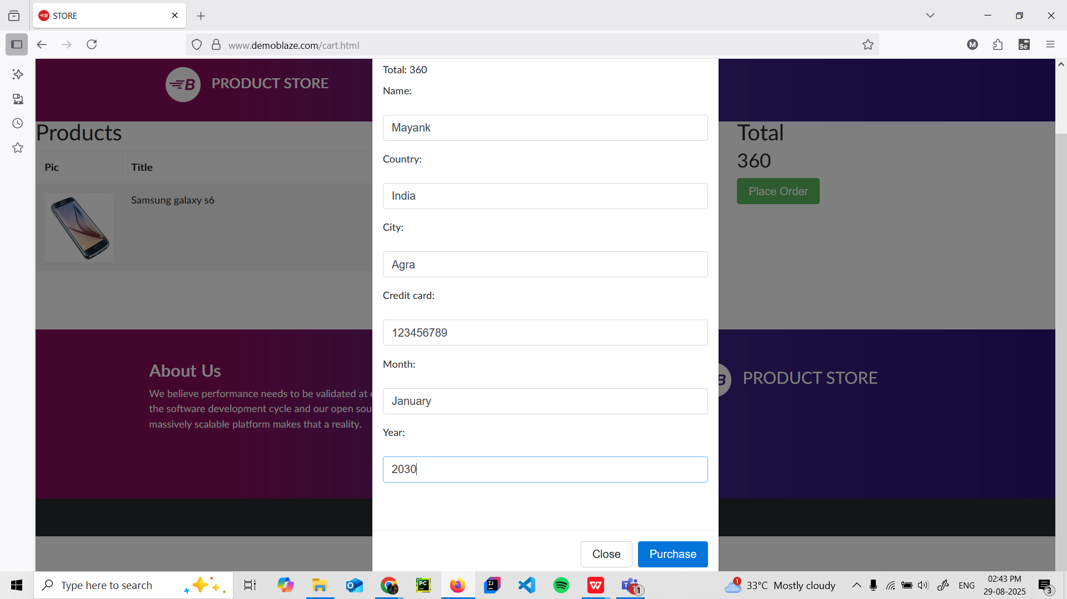

Purchase successful card is shown with id, amount, card number, name, date

